|  |  |
| --- | --- |
|  | **YEAR 12 MATHEMATICS SPECIALIST**  **SEMESTER TWO 2017**  **QUESTIONS OF REVIEW 7: Differential Equations** |

Name: _______________________

Thursday 31st August Time: 35 minutes Mark /28

Calculators assumed.

### [10 marks – 3, 3, 2 and 2] – based on 2016 WACE paper

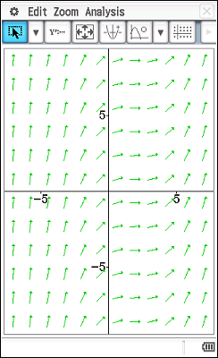This slope field represents the family of polynomials  with  and 

#### Explain why takes the form and evaluate *a* and *b*

#### Use Euler’s method, with an increment of to estimate , starting from

|  |  |  |  |
| --- | --- | --- | --- |
| *x* |  |  |  |
| 0 | 3 |  |  |
| 0.2 |  |  |  |
| 0.4 |  |  |  |
| 0.6 |  | - | - |

#### Determine given

#### Compare the actual value of with your estimate in (b) and explain the difference.

### [18 marks – 2, 4, 2, 1, 1, 1, 1, 3, 1, 1 and 1] – based on 2016 SA Specialist paper

#### A country’s population growth depends on the internal growth rate *r* and the number of immigrants *I*, so that

#### Use separation of variables to show that

#### Hence solve the differential equation and show that where

#### A country in 2017 has million, million and

#### Estimate the population in 5 years time (the year 2022)

#### Estimate the population in 50 years time

#### Identify one assumption in these estimates

#### How reliable is the model in the longer term?

#### A logistic equation for this country’s population is derived from with a 2017 population of million and an increased *r* value to include immigration.

#### What is the maximum population?

#### Estimate the population in 5 years time (2022) and after 50 years

#### What is the major difference between these logistic results and the earlier model?

#### A combined equation has

#### Draw the solution curve with million on this slope field.

#### How do the results from this model compare with the logistic model?